Ques 1 : Write a program to print all keys within a given range [L, R] using a B-Tree.

Optimize to avoid visiting unnecessary nodes.

Analyze time complexity for best and worst cases

class BTreeNode {
constructor(t, isLeaf = false) {
this.t = t; // Minimum degree
this.isLeaf = isLeaf; // Boolean
this.keys = []; // Sorted array of keys
this.children = []; // Array of child nodes
}

// Utility: In-order traversal (for testing/debug)
traverse() {
const result = [];
if (this.isLeaf) {
return [...this.keys];
}
for (let i = 0; i < this.keys.length; i++) {
result.push(...this.children[i].traverse());
result.push(this.keys[i]);
}
result.push(...this.children[this.keys.length].traverse());
return result;
}

/**
* Split a full child at index i into two nodes and
* promote the middle key to this node.
*/
splitChild(i) {
const t = this.t;
const y = this.children[i];
const z = new BTreeNode(t, y.isLeaf);

const medianKey = y.keys[t - 1];

z.keys = y.keys.slice(t);
y.keys = y.keys.slice(0, t - 1);

if (!y.isLeaf) {
z.children = y.children.slice(t);
y.children = y.children.slice(0, t);
}
this.children.splice(i + 1, 0, z);
this.keys.splice(i, 0, medianKey);

console.log(`Split child at index ${i}, promoted key ${medianKey}`);
}

/**
* Insert key k into this node, assuming node is not full.
*/
insertNonFull(k) {
let i = this.keys.length - 1;

if (this.isLeaf) {
while (i >= 0 && k < this.keys[i]) {
i--;
}
this.keys.splice(i + 1, 0, k);
console.log(`Inserted ${k} into leaf ${JSON.stringify(this.keys)}`);
} else {
while (i >= 0 && k < this.keys[i]) {
i--;
}
i += 1;

if (this.children[i].keys.length === 2 * this.t - 1) {
console.log(`Child ${i} full when inserting ${k}, splitting...`);
this.splitChild(i);

if (k > this.keys[i]) i++;
}
this.children[i].insertNonFull(k);
}
}
}

class BTree {
constructor(t) {
this.t = t;
this.root = new BTreeNode(t, true);
}

insert(k) {
const r = this.root;
if (r.keys.length === 2 * this.t - 1) {
// Root full: grow tree height
const s = new BTreeNode(this.t, false);
s.children.push(r);
this.root = s;
console.log(`Root full when inserting ${k}. Splitting root...`);
s.splitChild(0);
s.insertNonFull(k);
} else {
r.insertNonFull(k);
}
}

traverse() {
return this.root.traverse();
}

/**
* Range query: returns all keys in [L, R].
* Prunes subtrees that cannot intersect the range.
*/
keysInRange(L, R, verbose = false) {
const results = [];
const visit = (node, minAllowed = -Infinity, maxAllowed = Infinity) => {
if (minAllowed > R || maxAllowed < L) {
if (verbose) {
console.log(`Pruned node with interval (${minAllowed}, ${maxAllowed})`);
}
return;
}

if (verbose) {
console.log(`Visiting node keys=${node.keys} interval (${minAllowed}, ${maxAllowed})`);
}

let currMin = minAllowed;
for (let i = 0; i < node.keys.length; i++) {
if (!node.isLeaf) {
visit(node.children[i], currMin, node.keys[i]);
}

const key = node.keys[i];
if (key >= L && key <= R) {
results.push(key);
if (verbose) console.log(` -> Key ${key} in range`);
}
currMin = key;
}
if (!node.isLeaf) {
visit(node.children[node.keys.length], currMin, maxAllowed);
}
};

visit(this.root);
return results;
}
}

// ------------------------- DEMO -------------------------

if (typeof require !== 'undefined' && require.main === module) {
const t = 3 // Minimum degree
const tree = new BTree(t);
const sequence = [10, 20, 5, 6, 12, 30, 7, 17];
console.log("Inserting sequence:", sequence);

sequence.forEach(k => {
console.log(`\n--- Inserting ${k} ---`);
tree.insert(k);
});

console.log("\nIn-order keys:", tree.traverse());

const L = 6, R = 17;
console.log(`\nKeys in range [${L}, ${R}] (verbose):`);
const keys = tree.keysInRange(L, R, true);
console.log("Result:", keys);
}
// -------------------------------------------------------

Output:
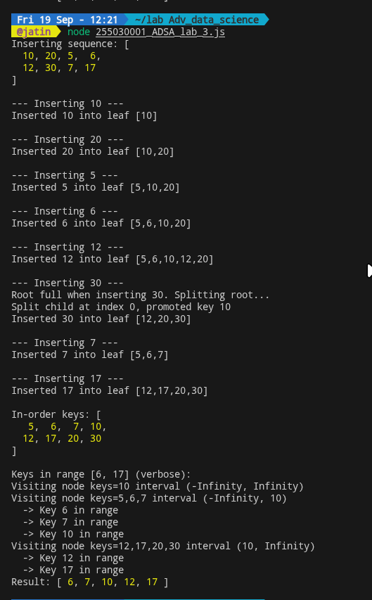

Time: Θ(logₜ n + k) best/average, Θ(n) worst
Space: Θ(logₜ n + k) (or Θ(logₜ n) if output is streamed)

